**DAILY ONLINE ACTIVITIES SUMMARY**

|  |  |  |  |  |  |  |  |  |
| --- | --- | --- | --- | --- | --- | --- | --- | --- |
| **Date:** | **12/06/2020** | | | | | **Name:** | **PRANEETA P HANDRAL** | |
| **Sem & Sec** | **4thSEM. & ‘B’ SEC.** | | | | | **USN:** | **4AL19CS401** | |
| **Online Test Summary** | | | | | | | | |
| **Subject** | | **Aadalitha Kannada** | | | | | | |
| **Max. Marks** | | **25** | | **Score** | | | **20** | |
| **Certification Course Summary** | | | | | | | | |
| **Course** | **Introduction to Cyber security** | | | | | | | |
| **Certificate Provider** | | | **Greatlearning Academy** | | **Duration** | | | **5 Hrs.** |
| **Coding Challenges** | | | | | | | | |
| **Problem Statement:** **Given two positive integer start and end. The task is to write a Python program to print all Prime numbers in an Interval.** | | | | | | | | |
| **Status: Executed.** | | | | | | | | |
| **Uploaded the report in Github** | | | | | **Yes** | | | |
| **If yes Repository name** | | | | | **LockdownCoding**  <https://github.com/praneetahandral/lockdowncoding> | | | |
| **Uploaded the report in slack** | | | | | **Yes** | | | |

**Online Test Summary:​** **18KAK49 online test was scheduled from 11:30 am t0 12:00 pm** . **The portion for the IA was all 10 module there were 25 questions and the time assigned was 30 minutes the questions were mcq type. There were 25 questions of 1 marks respectively.**

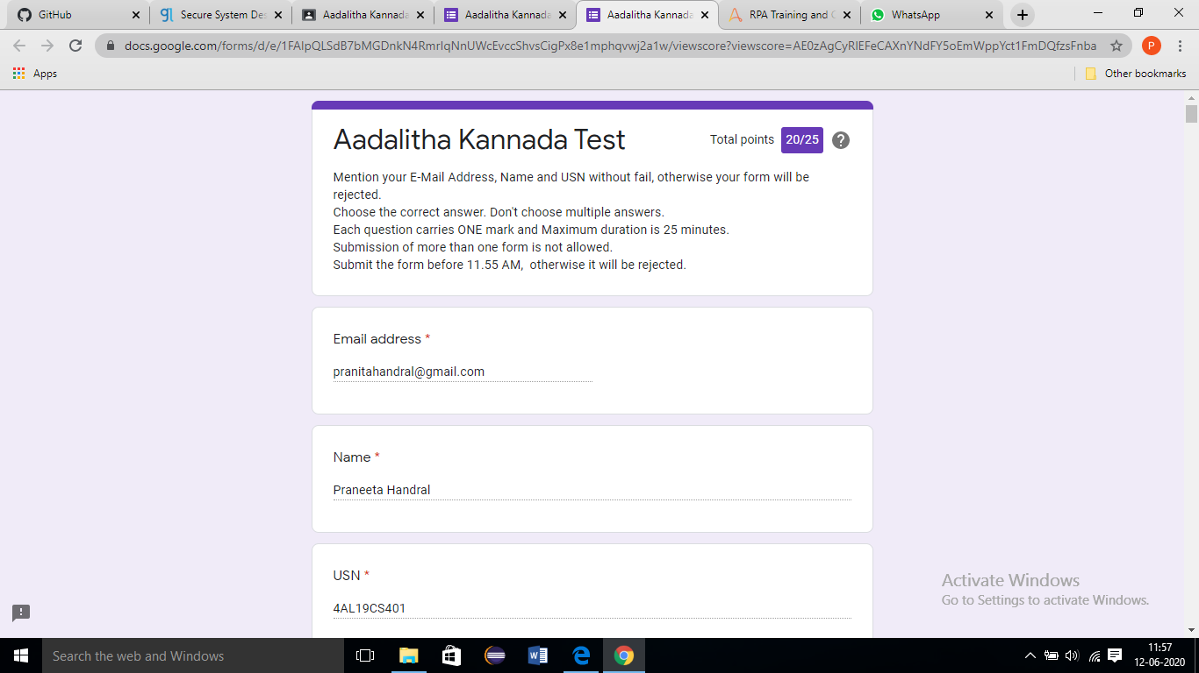

**Online Certification Course Summary**: I have taken my Online Certification Course in **Great learning academy** the course which I have opted is **Introduction to Cyber security**. Course contains videos, tutorials, assessments and quiz. Today I have learn about **Secure System Design** and **Introduction to Cryptography** and **Threats and Vulnerabilities and also** today I am attended the test for completion of course and also I score 9 marks in the test finally today I am complete the **Introduction to Cyber security** certification course I received certification for **Grate learning academy** and I put snapshot of the certificate below:

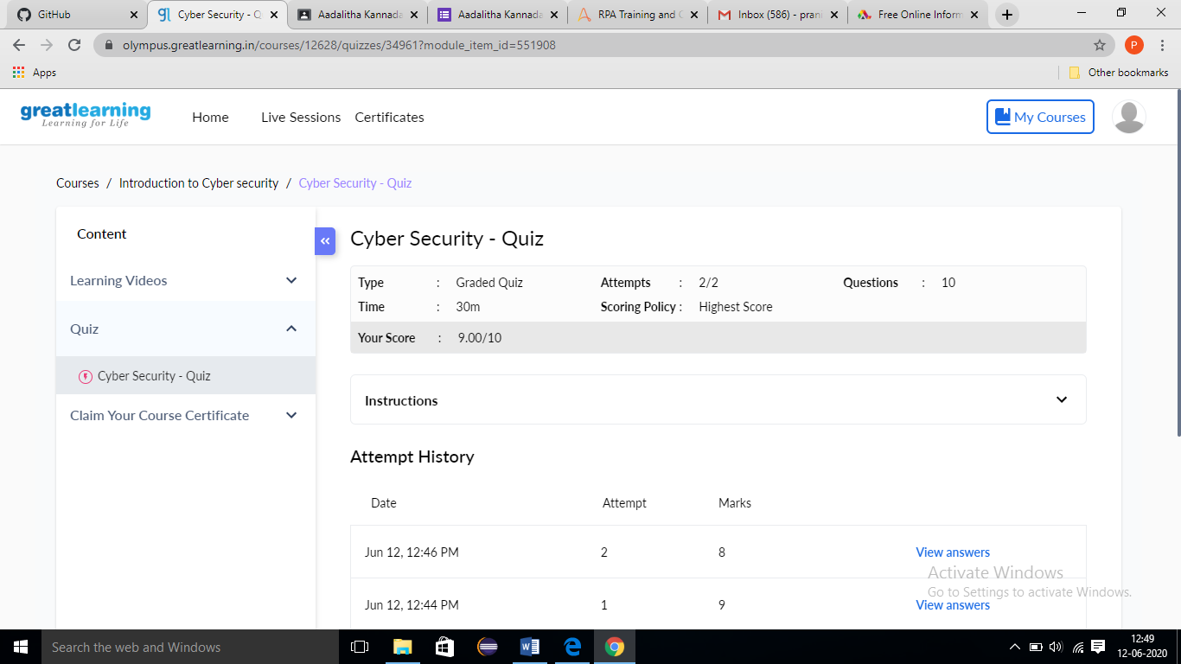

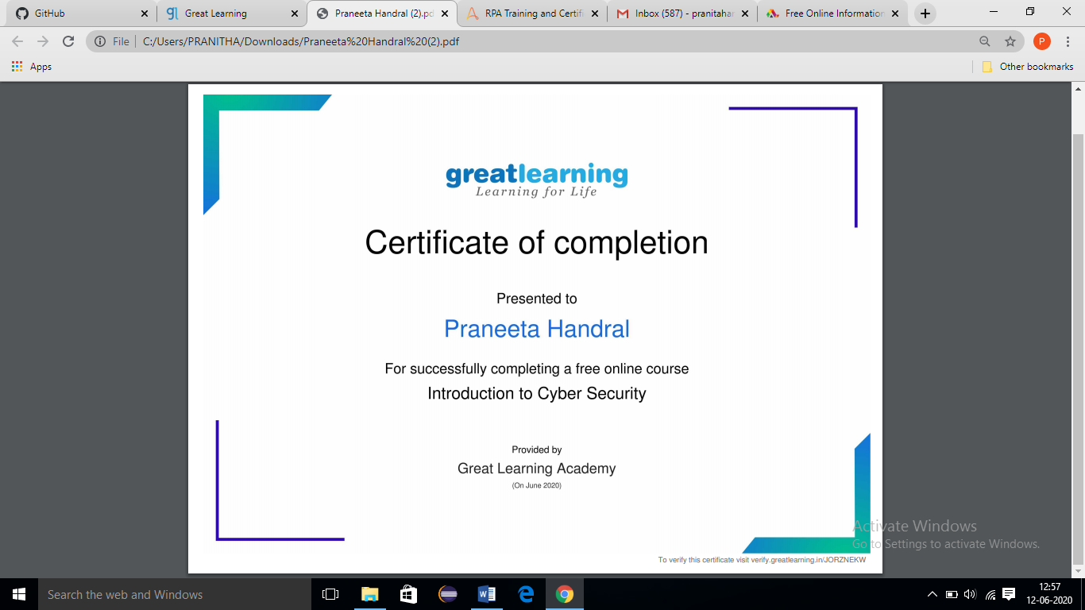

**Online Coding Summary: Today I received one program from Prof.** **Vasudev** **CSE Dept. The program is mentioned above. to my GitHub repository and I’ve shared the snapshot below.**

